Data set: NumberTransformations. It has two tables: ‘Data’ and ‘Numbers’.

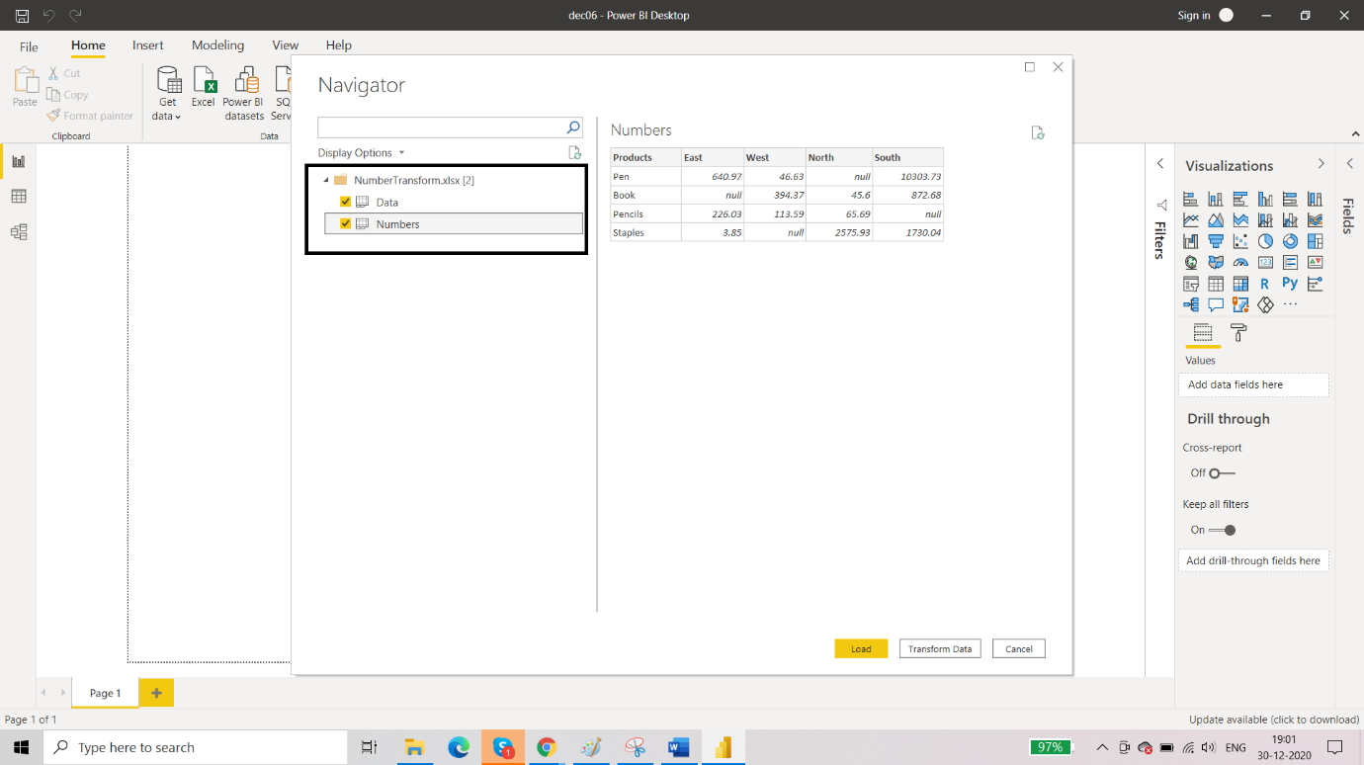

1. In the Data table. Update the column headers.

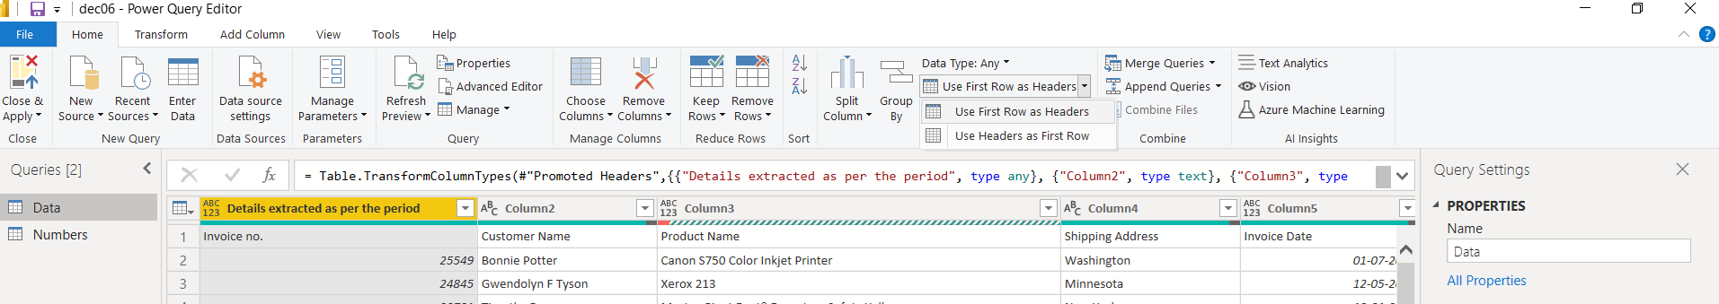

So we will get:

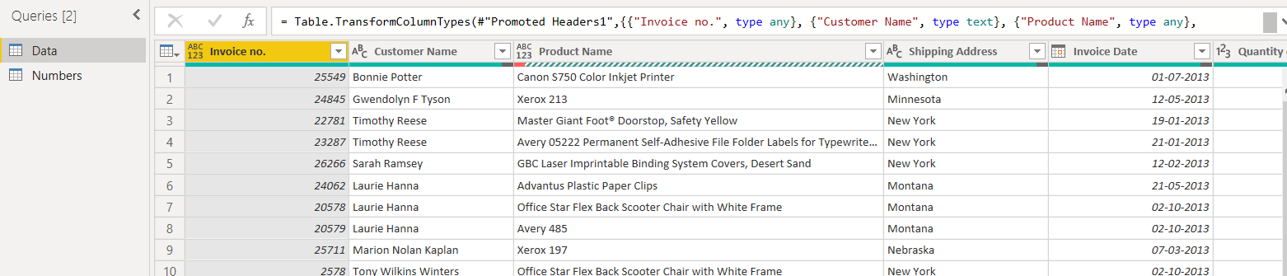

1. Select the column with error and remove the errors:

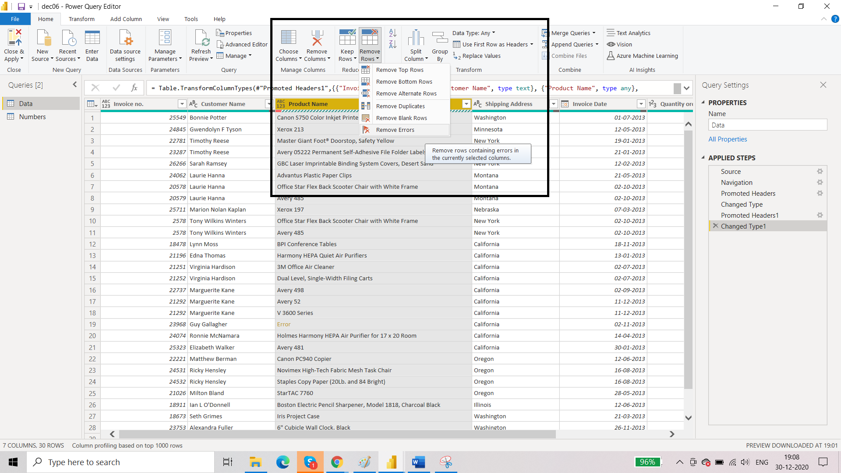

So we will get the following:

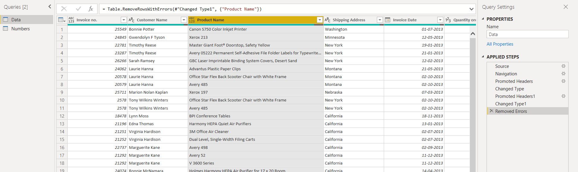

1. Remove the bottom two rows:

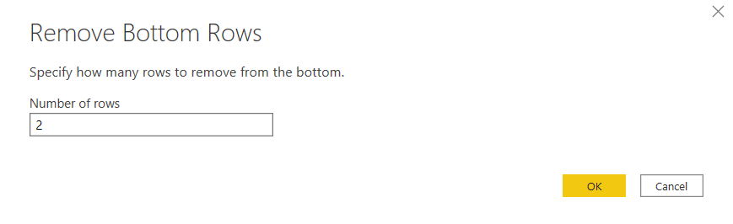

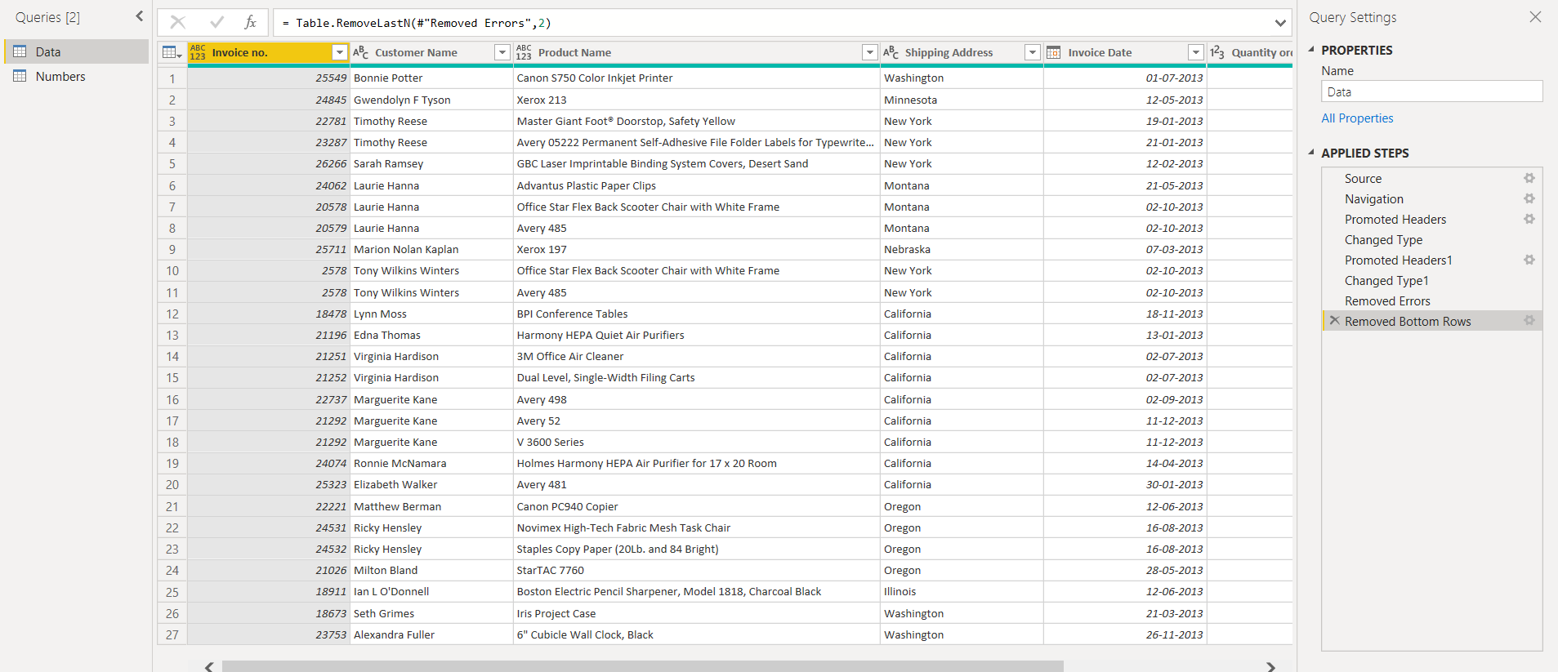

**Transform: Number Column-** this will work on single column at a time (will not work on multiple column)

**Add Column: From Number-**  This will work for multiple columns too.

TRANSFORM

1. Transform: Number Column – Statistics: It will always return a scalar value or aggregate value.

Select the column for which you wish to apply the statistics. Here we are calculating the average.

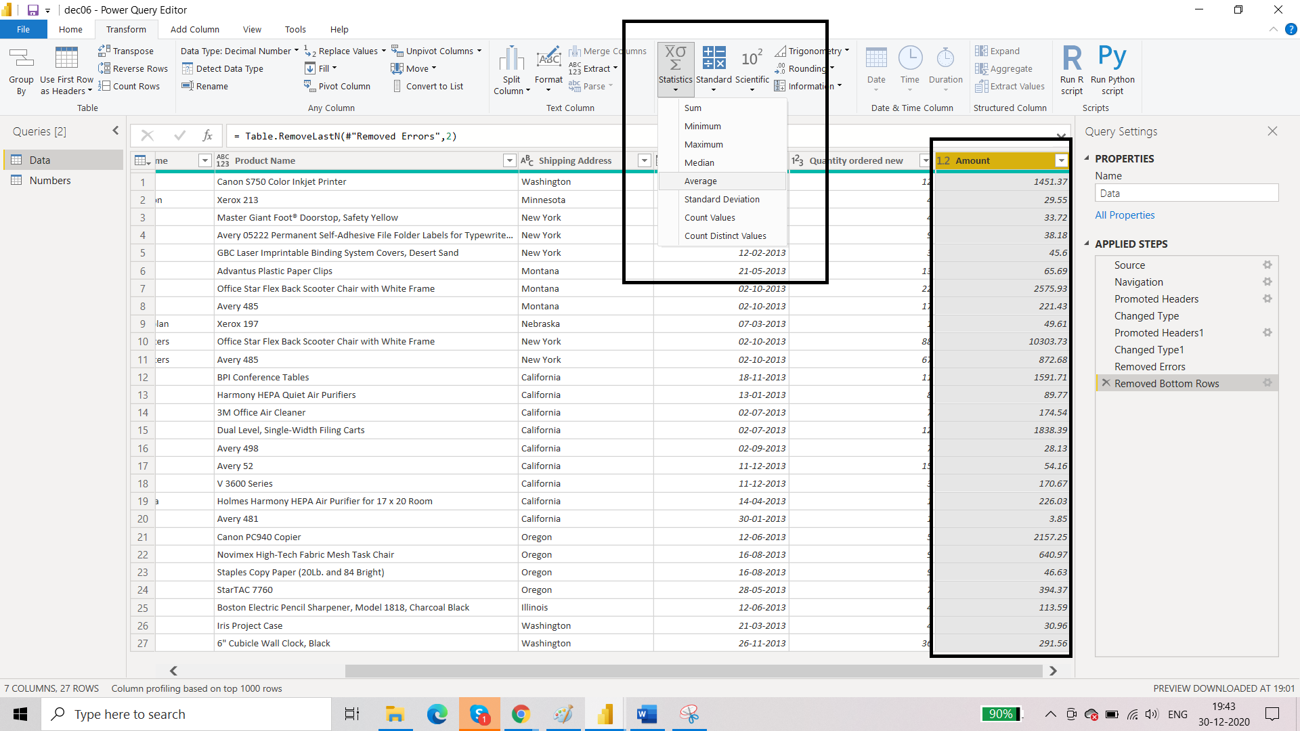

So now we will get:

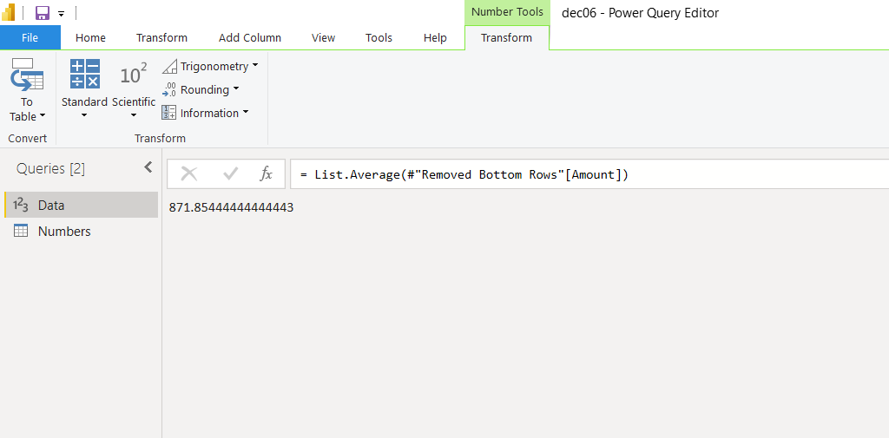

1. Transform: Number Column 🡪 Standard 🡪 Multiply

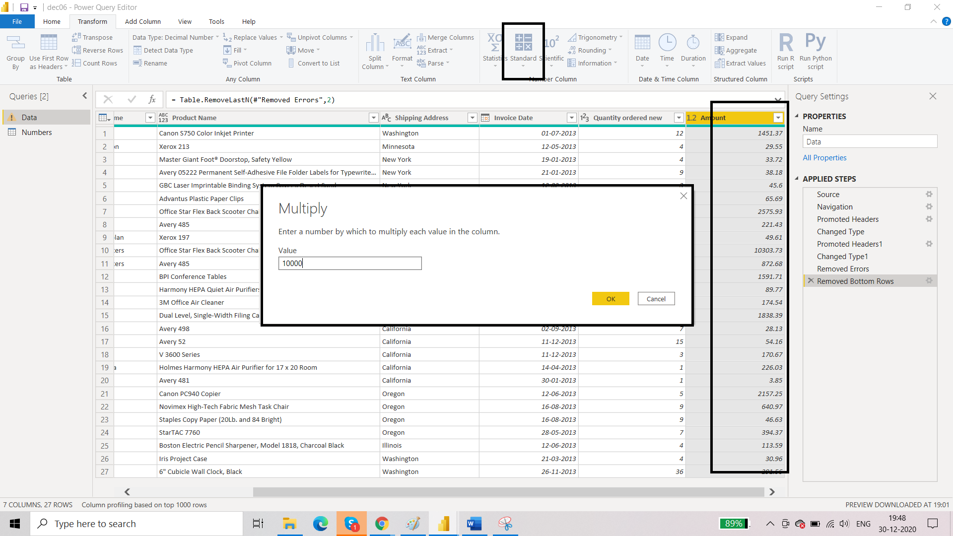

So now we will get:

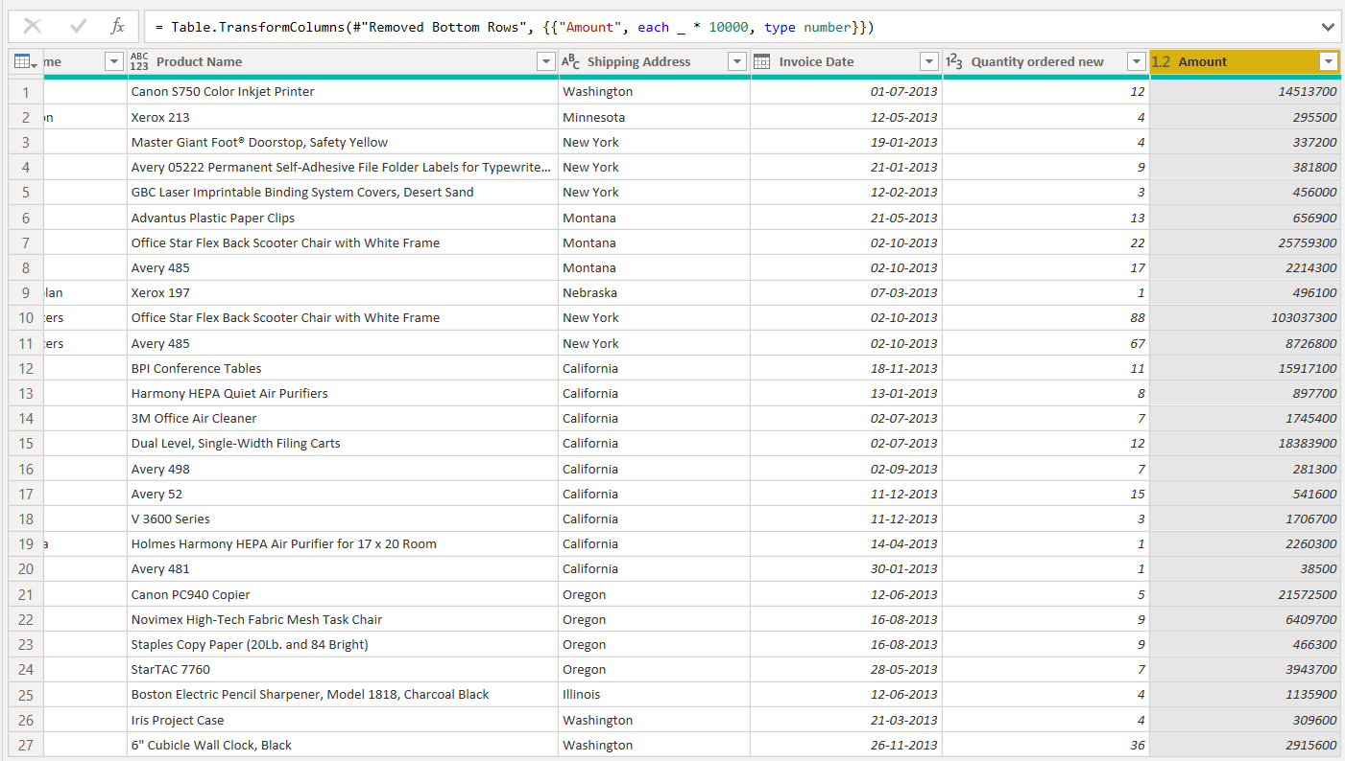

1. Round up – rounds up to next available whole number
2. Round down- rounds down to last whole number
3. Is even – gives TRUE for even number and FALSE for others
4. Is odd- given TRUE for odd number and FALSE for others
5. Sign- given 1 for positive value and 0 for negative value

ADD COLUMN

1. Go to Numbers table. Select East, West, North, South and from add column🡪 standard 🡪 add, we will get the summation of the values.

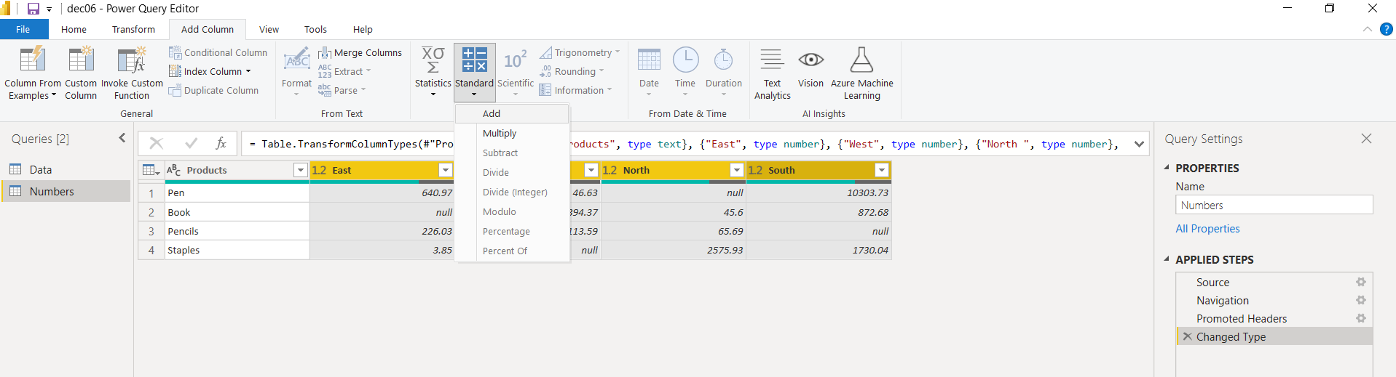

And we will get a separate column added showing the summed-up values:

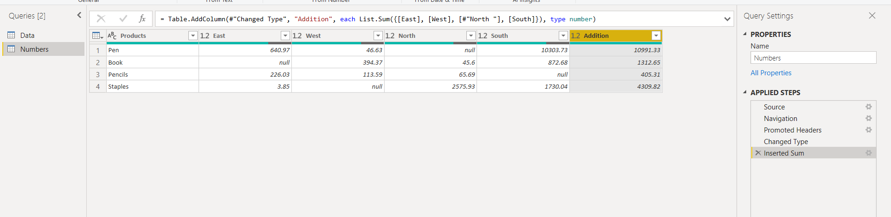

1. Now let us take the case of adding 2 columns. Select East and West and add those column:

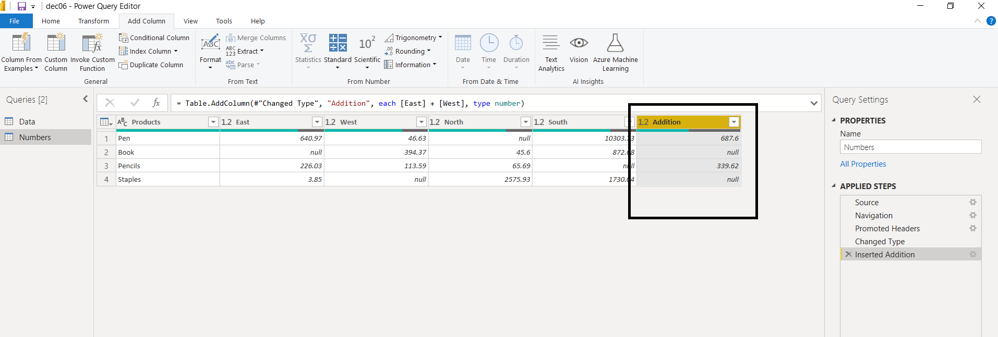

We notice that there are null values for the addition of a number and a null. So addition works well in cases where there are more than two columns. This means that we are trying to add more than two values.

But like a case here, we are adding two columns and one of the row can contain null value. So we can solve this problem by using CUSTOM COLUMN.

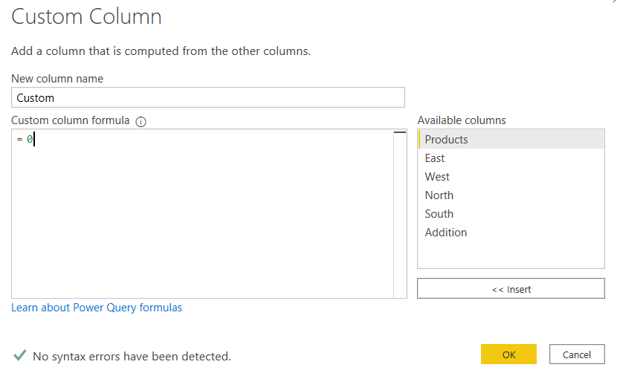

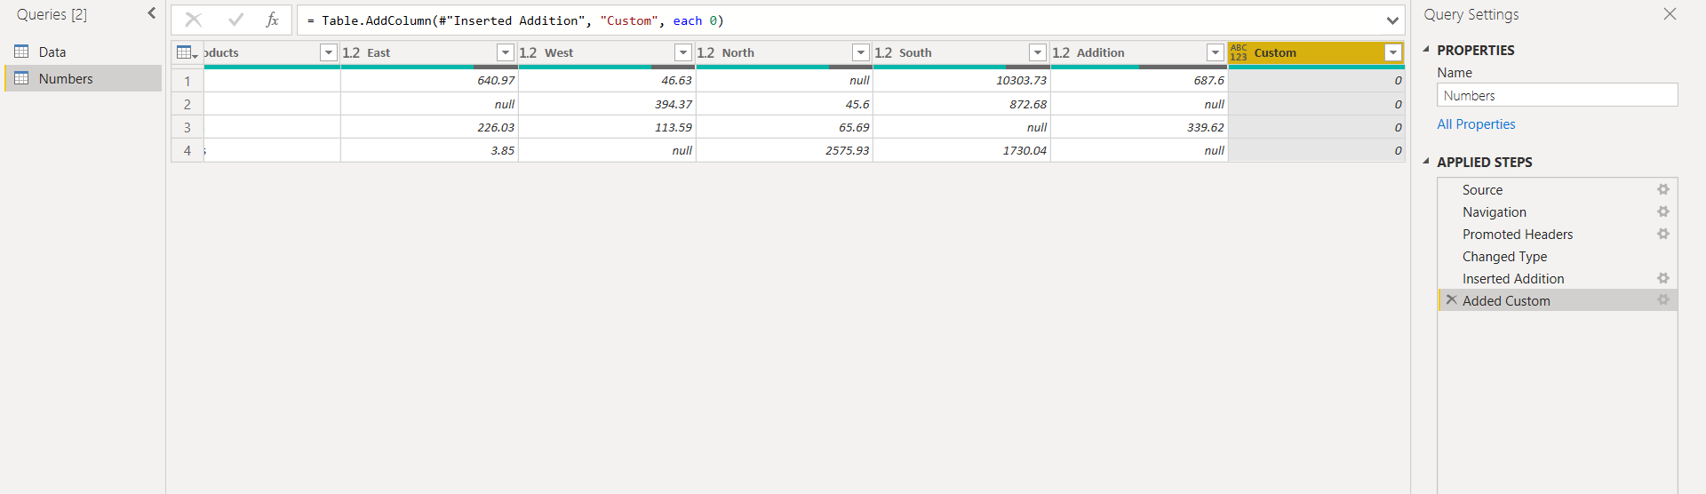

Custom column will be added. Now along with the 2 columns we had previously, we can use this custom column for addition and avoid the problem of getting null values as the output.

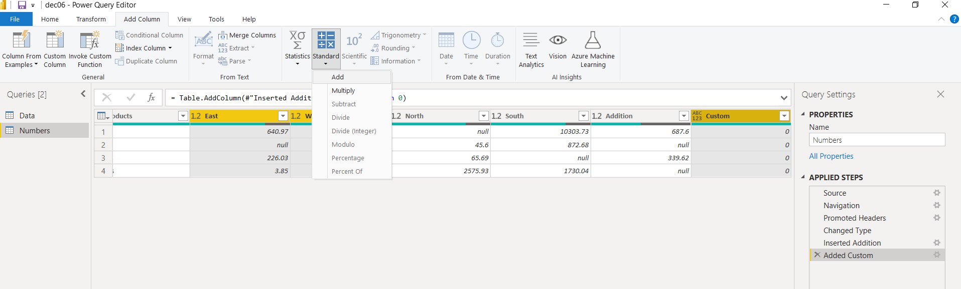

Now the result is:

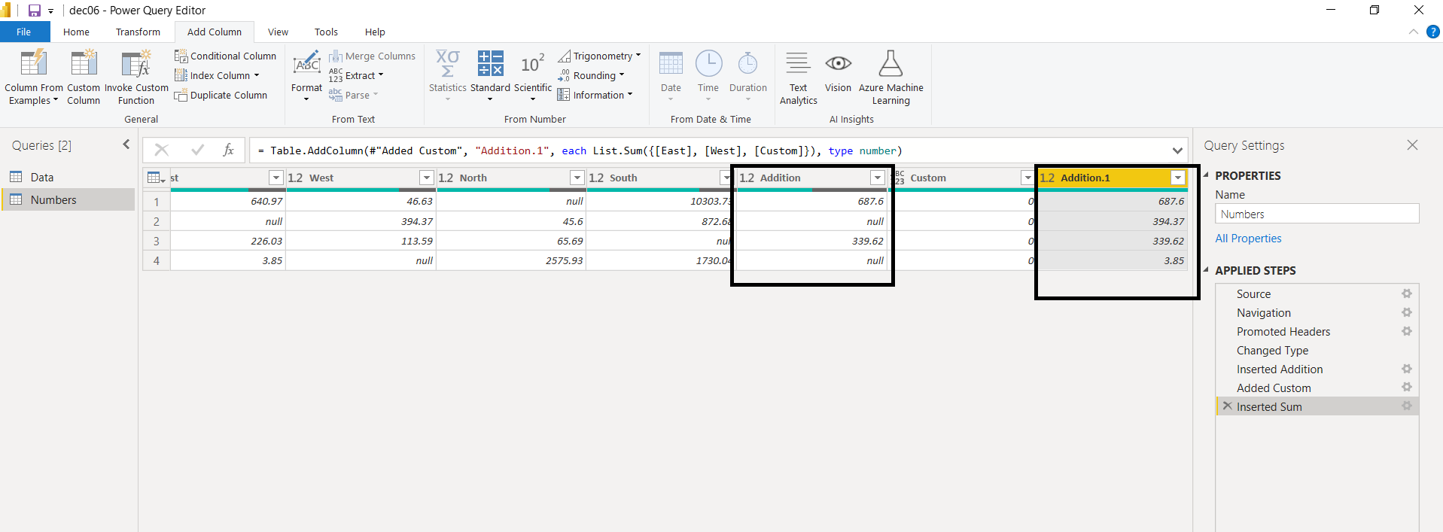

It is although preferable to use the custom column with value 1 and then decrease the value of resultant column with by one.

1. Go to Data and select Invoice Date and click on ‘remove other columns’.

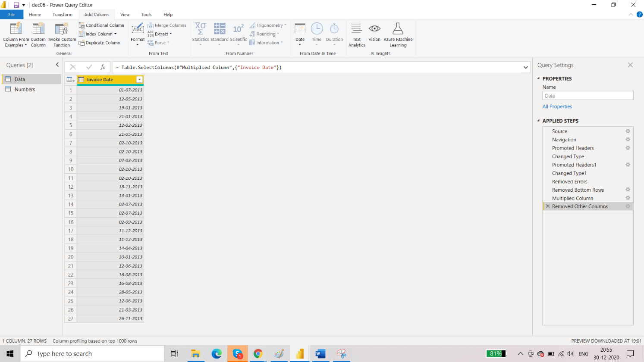

Go to Add Column 🡪 Date 🡪 Start of the Year

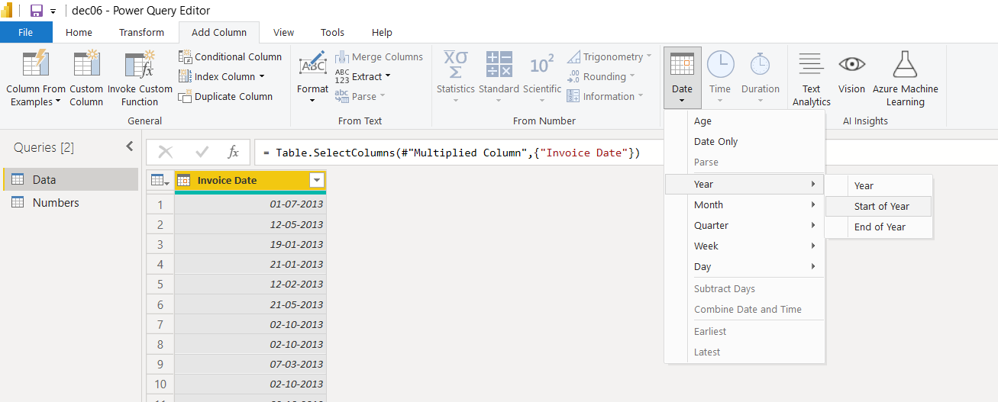

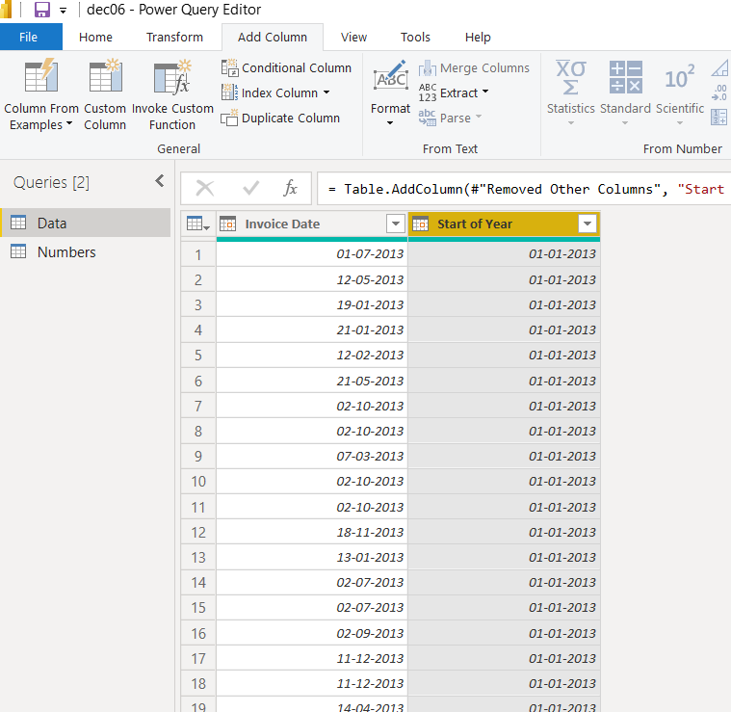

1. Now we want to find the number of days between start of the year and invoice date.

Select both the columns 🡪 add column 🡪 date 🡪 subtract days

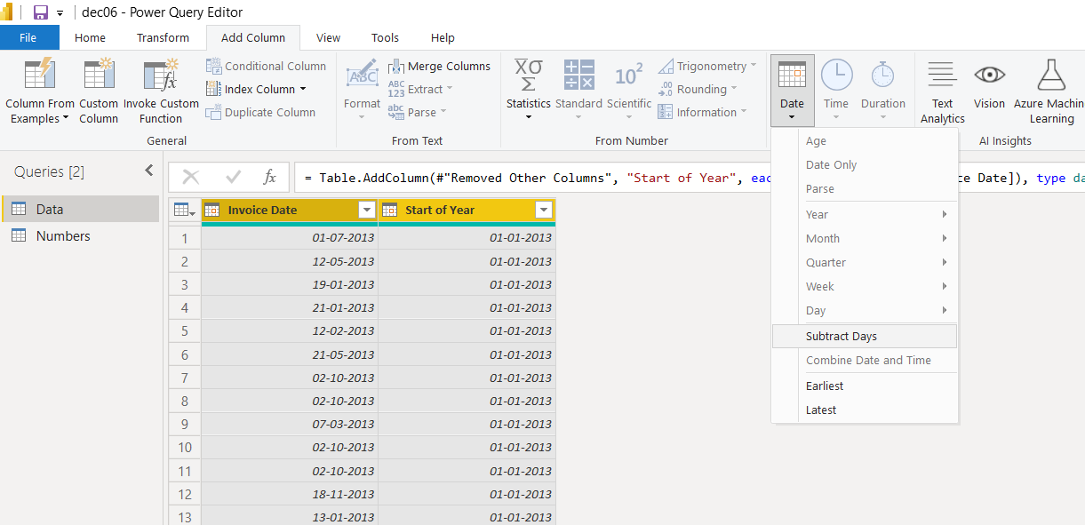

Result:

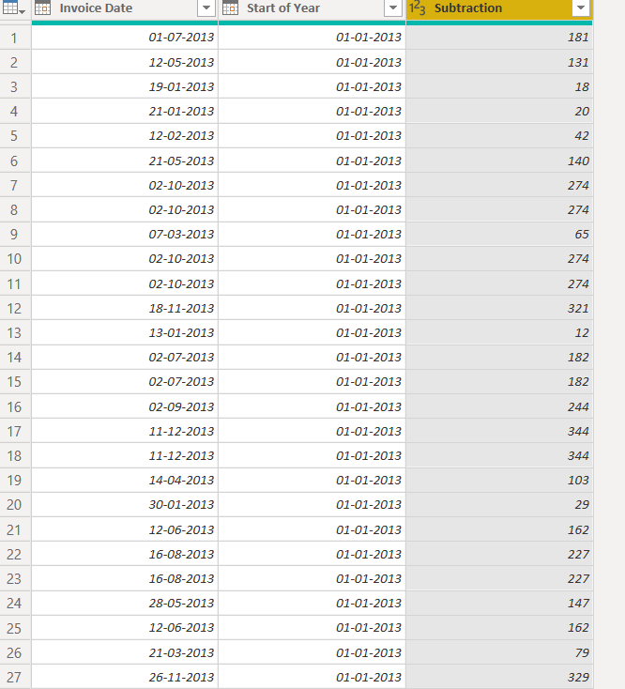

1. Now the days values that we got as a subtraction from invoice date and start of the year, we want those days in hours.
2. we will first the change the data type of Subtraction column as duration. Go to Transform🡪 data type 🡪 duration.

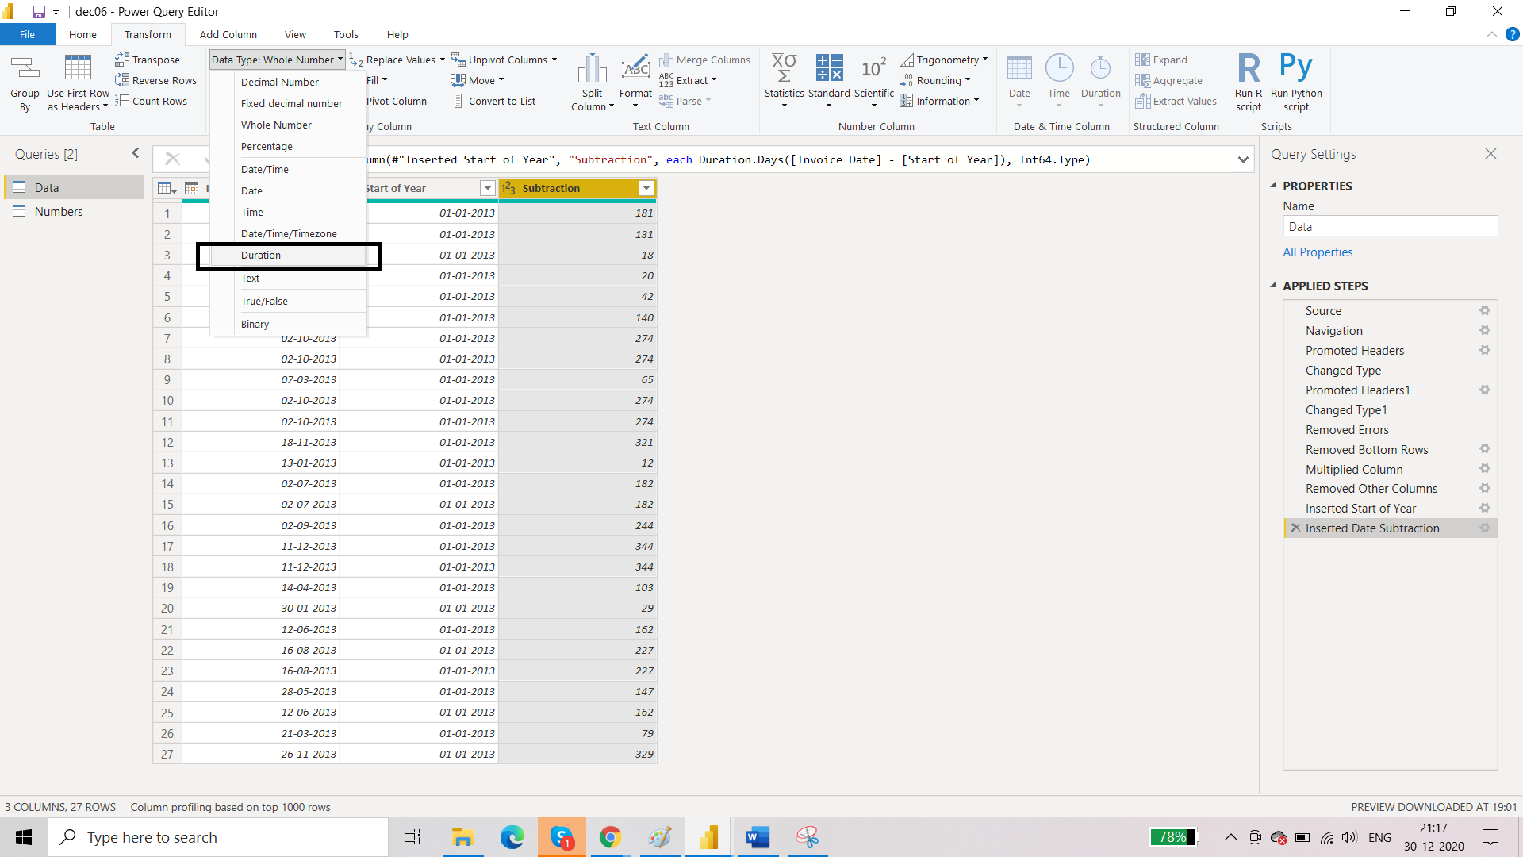

Result:

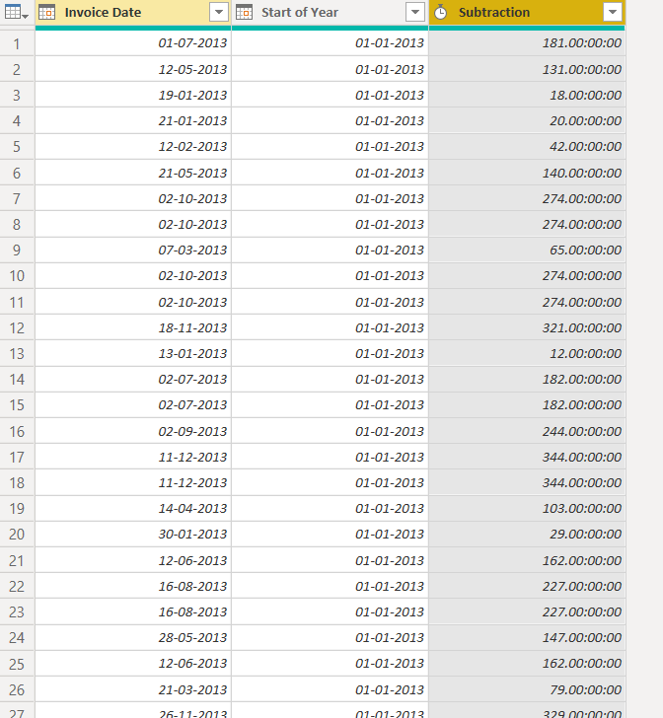

1. Now from add column 🡪 duration 🡪 total hours

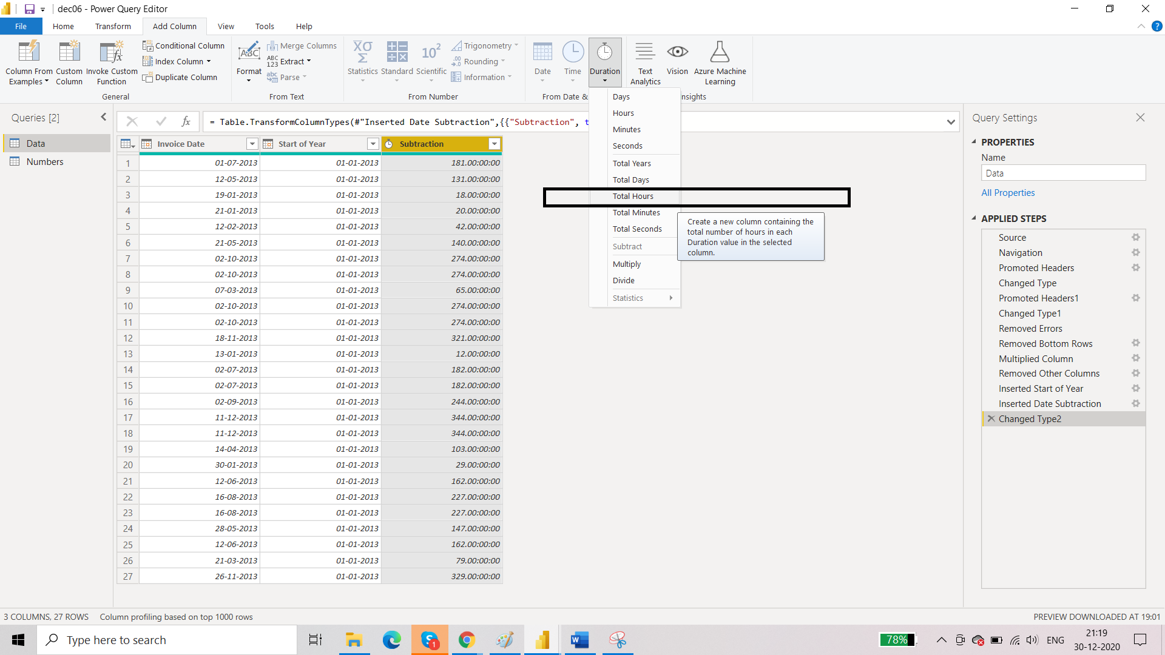

Result:

